Life-long Learning / Aprendizaje sin fin
Cherokee Street
Communities: Participate in Multilingual Communities at Home & Around the World

Task: Students will show evidence of becoming life-long learners by using Spanish for personal enjoyment and enrichment and will reflect on and share their experiences with classmates.

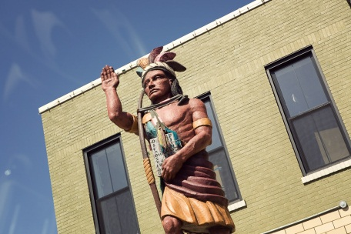
Process: Students will learn about areas of personal interest by consulting various Spanish sources and/or attending events and then share their reflections on their learning experiences with classmates.

Things to keep in mind if you choose go to Cherokee St. for your project:
- Read this packet in advance, preferably online, so you can click on the links.
- Before you go, watch this You Tube video. http://www.youtube.com/watch?v=B0GTdbZzZxY
- Make plans to go midday so you can have lunch there. Don’t go late; most stores close at 5:00 PM.
- Greeting store owners or workers in Spanish as you enter a store will go a long way toward making this a great experience. You will be surprised how friendly people will be to you if you show respect to them by trying to speak Spanish. It’s OK to make mistakes. No one cares if you are perfect.
- Take this packet, a pen or pencil, and a camera with you when you go to Cherokee St. A clipboard (or something you can use to write on) would also be helpful.
- Signage is very poor. You will need the attached map.
- Complete the attached Scavenger Hunt worksheet while you are there. Incomplete worksheets are will not be accepted.
- Eat lunch at either La Vallesana or Garduño’s Mexican Restaurant.
- Be observant. Write your answers to the reflection questions as soon as possible after you go so that the experience is fresh in your mind.

- Your completed project is due October 4th, but can be turned in any time before that date.

Directions to Cherokee Street
- Go east on I-44 to Jefferson Ave.
- Exit at Jefferson Ave. and go right (south).
- Turn right on Cherokee Street, just past the statue of the Cherokee Indian (above).
- Continue straight 3 blocks and then turn right on Iowa Ave.
- Park in the lot of the left-hand side of the street that has a mural along the back of it.
Mapa de Cherokee St.
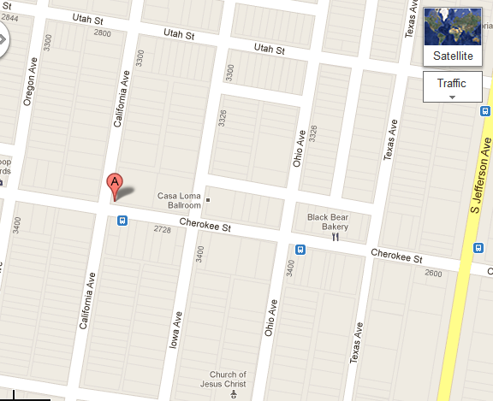
E
D
J
I
K
H
G
F
C
B

- El Torito (supermercado y taquería)  - Parking Lot with mural  - Casa Loma Ballroom  - Siete Luminarias (taquería)  - Garduños Mexican Restaurant  - La Vallesana (taquería) | - Gooolll (tienda de fútbol)  - La Mejor Bota Vaquera  (tienda de ropa vaquera)  - Latin Beauty & Barber Shop  - Carnicería Latinoamericana  - El Chico Bakery

Description and Reflection of Your Experience
Answer the questions in English or Spanish. Please TYPE your answers.
1. ¿Por qué escogiste ir a Cherokee Street?
Why did you choose to go to Cherokee Street?
2. Describe tu experiencia en la calle Cherokee. ¿Qué observaste? ¿Qué te sorprendió?
Describe your experience Cherokee St. What did you observe? What surprised you?
3. Ask a parent or other responsible adult to sign here to prove that you have gone to Cherokee St. and/or submit a picture of YOU on Cherokee St.
X _______________________________________________________
4. ¿Le recomendarías esta experiencia a otro estudiante? ¿Por qué sí o por qué no?
Would you recommend this experience to another student? Why or why not?
5. Si tuvieras que resumir tu experiencia en una frase, qué dirías?
If you had to summarize your experience in one sentence, what would you say?

Life-long Learning Project – Cherokee Street Scavenger Hunt

Scavenger Hunt Activities
- Parking Lot Mural (Iowa Ave., north of Cherokee)
The theme of this mural is Latin music. List and describe 3 images from the mural that illustrate this theme.
- ____________________________________________________________________________________
- ____________________________________________________________________________________
- ____________________________________________________________________________________

- Go across the street to the Casa Loma Ballroom. Look at the posters on the door advertising upcoming bands.
Are there any upcoming Latino bands that will be preforming here? YES NO
If yes, what is the name of the band? ________________________________________________________
Where is the band from? __________________________________________________________________
What date will they be performing? _________________________________________________________
- El Torito (supermercado y taquería) Turn right on Cherokee.
Make a list of a variety of different products sold that you would not see at your local grocery store.
- _____________________________________ d. _____________________________________
- _____________________________________ e. _____________________________________
- _____________________________________ f. _____________________________________
- Eat at a Mexican restaurant and order in Spanish. Here are some good choices.
- Siete Luminarias (taquería) http://www.riverfronttimes.com/2012-03-15/restaurants/siete-luminarias-mexican-restaurant-burns-bright-on-cherokee-street/
- Garduño’s Mexican Restaurant – good for fish
- La Vallesana (taquería)
I ordered my meal in Spanish!
Signature of waiter: X___________________________________________
- Is there a daily special? YES NO
- If yes, what is it? __________________________________________________________________________
- What did you have to eat? __________________________________________________________________
- How was it? _____________________________________________________________________________
________________________________________________________________________________________

OPTIONAL: Gooolll (tienda de fútbol)
Next to La Vallesana on Iowa Ave.
Describe. _______________________________________________________________________________
______________________________________________________________________________________________________________________________________________________________________________
- La Mejor Bota Vaquera (Best Cowboy Boot) (poor signage – Check your map.)

List items that are sold in this store.

- ______________________________
- ______________________________
- ______________________________
- ______________________________
Take a picture of your favorite boots!

- Latin Beauty & Barber Shop
What services are offered here other than the obvious hair care options? HINT: Look at the sign outside.
- ______________________________
- ______________________________
- ______________________________
- Carnicería Latinoamericana (Corner of Cherokee and California)
What does “Carnicería” mean? ____________________________________________________________________
How is this store different from El Torito? ____________________________________________________________
______________________________________________________________________________________________________________________________________________________________________________________________
OPTIONAL: El Chico Bakery (Your school gets “Pan de los Muertos” from this store every year for Day of the Dead.)
- Have a snack.
- Ask the worker to explain the names of several different items in Spanish.

